**SBN High Risk Work Checklist User Guide**

This checklist is meant for SAF’s personnel to utilise while performing safety inspections for the top High-Risk Works

**Step 1**: Identify the type of work to be assessed and click on the relevant icon. This would route you to the relevant google form to be filled.

For works not listed in the checklist, you may identify the most suitable one. Otherwise, do seek advice from your superiors.

**Step 2**: Fill up the list according to fields listed. Ensure that all * fields are completed

Ensure that the type of work is correct

Pictorial here for visual representation.

Specify the specific Block & unit number.

For common areas, Specify the block, area, and closest unit number

(E.g Blk 604, Walkway along #01-04)

**Step 3**: Perform checks according to the checklist.

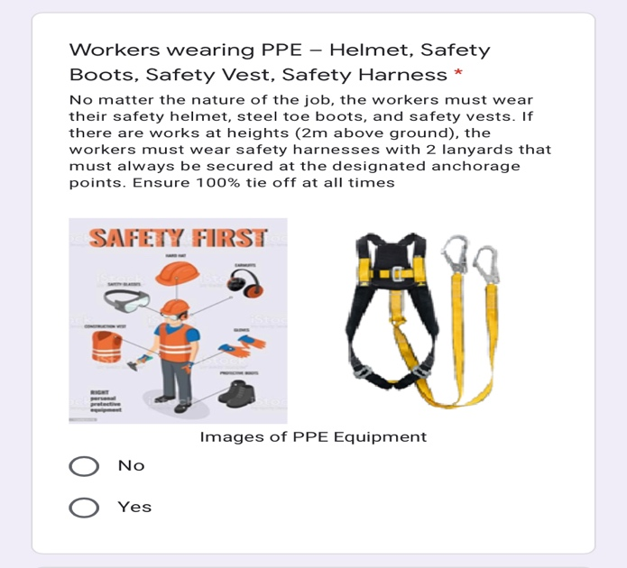

For Noncompliance, answer “No”. Stop work immediately and inform your superior.

Read the description and reference to the illustration for the checks.

**Step 4**: Submit the completed form.

